# Part 4 – Basic Authentication

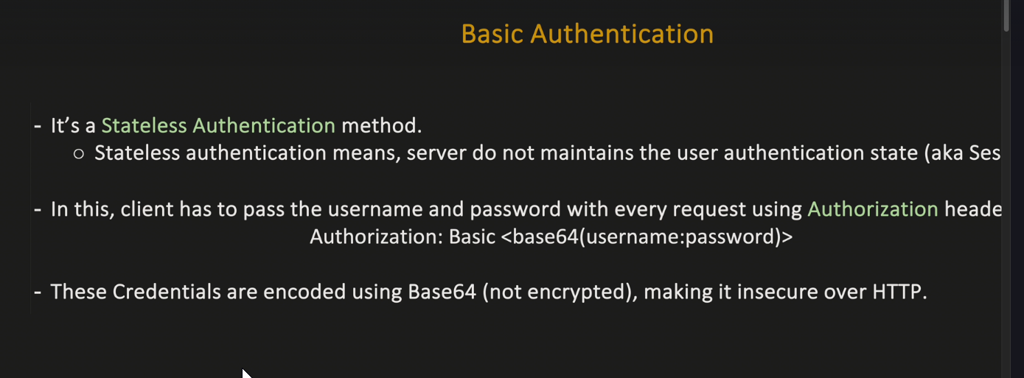

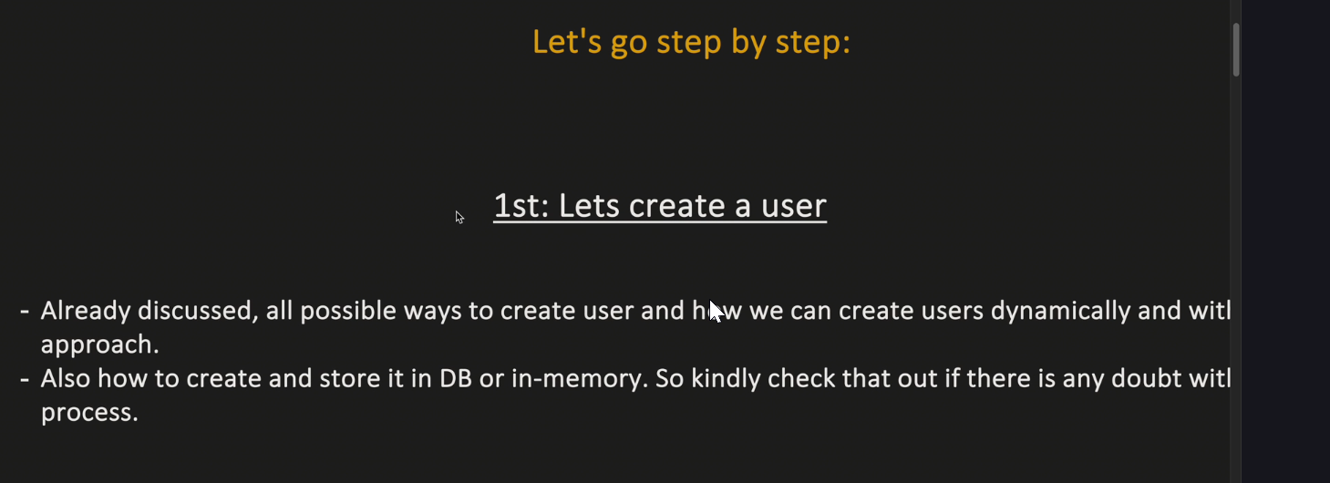

3.

